BANK LOAN REPORT QUERY DOCUMENT
- BANK LOAN REPORT | SUMMARY
KPI’s:
Total Loan Applications
SELECT Count(id) as Total_Application From Bank_oan_data;
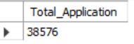
MTD Loan Applications
SELECT Count(id) as Total_Application_MTD From Bank_oan_data
WHERE MONTH(issue_date)= 12;
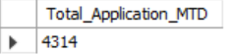
PMTD Loan Applications
SELECT Count(id) as Total_Application_PMTD From Bank_oan_data
WHERE MONTH(issue_date)= 11;
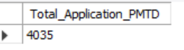

Total Funded Amount
SELECT sum(loan_amount) as Total_funded From Bank_oan_data;
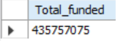

MTD Total Funded Amount
SELECT sum(loan_amount) as Total_funded_MTD From Bank_oan_data
WHERE MONTH(issue_date) =12;
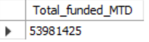
PMTD Total Funded Amount
SELECT sum(loan_amount) as Total_funded_PMTD From Bank_oan_data
WHERE MONTH(issue_date) =11;
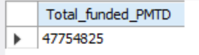
Total Amount Received
SELECT sum(total_payment) as Total_Amt_Received From Bank_oan_data; 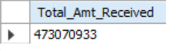
MTD Total Amount Received
SELECT sum(total_payment) as Total_Amt_Received_MTD From Bank_oan_data
WHERE MONTH(issue_date) = 12;
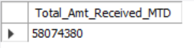
PMTD Total Amount Received
SELECT sum(total_payment) as Total_Amt_Received_PMTD From Bank_oan_data
WHERE MONTH(issue_date) = 11;
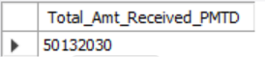

Average Interest Rate
SELECT round(avg(int_rate)*100,2) as AVG_RATE From Bank_oan_data;
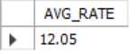
MTD Average Interest
SELECT round( avg(int_rate)*100,2) as AVG_RATE_MTD From Bank_oan_data
WHERE MONTH(issue_date)=12;
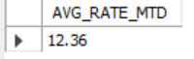
PMTD Average Interest
SELECT round( avg(int_rate)*100,2) as AVG_RATE_MTD From Bank_oan_data
WHERE MONTH(issue_date)=11;
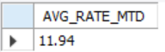

Avg DTI
SELECT round(avg(dti)*100,2) as AVG_DTI From Bank_oan_data;
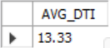

MTD Avg DTI
SELECT round(avg(dti)*100,2) as AVG_DTI From Bank_oan_data
WHERE MONTH(issue_date)= 12;
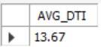

PMTD Avg DTI
SELECT round(avg(dti)*100,2) as AVG_DTI From Bank_oan_data
WHERE MONTH(issue_date)= 11;
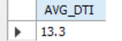

GOOD LOAN ISSUED
Good Loan Percentage
-- by using subquery;
SELECT (SELECT Count(id) From Bank_oan_data WHERE loan_status = "Fully Paid" or loan_status = "Current")/ Count(id) *100
as Good_Loan_Percent
From Bank_oan_data;

By using case:
SELECT round(Count( case when loan_status = "Fully Paid" or loan_status= "Current" then id end)/Count(id) * 100,2) as Good_Loan_Percent
From Bank_oan_data;

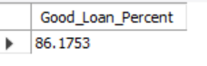
Good Loan Applications
SELECT Count(id) as Good_loan_Application From Bank_oan_data
WHERE loan_status = "Fully Paid" or loan_status = "Current";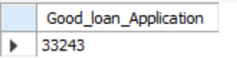
Good Loan Funded Amount
SELECT sum(loan_amount) as Good_loan_funded From Bank_oan_data
WHERE loan_status = "Fully Paid" or loan_status = "Current";


Good Loan Amount Received
SELECT sum(total_payment) as Good_loan_AMT_Received From Bank_oan_data
WHERE loan_status = "Fully Paid" or loan_status = "Current";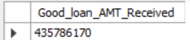

BAD LOAN ISSUED
Bad Loan Percentage
SELECT round(Count( case when loan_status = "charged Off" then id end)/ Count(id) * 100,2) as Bad_Loan_Percent
From Bank_oan_data;
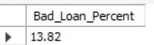
Bad Loan Applications
SELECT Count(id) as Total_Bad_application From Bank_oan_data
WHERE loan_status = "charged off";
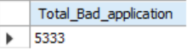
Bad Loan Funded Amount
SELECT sum(loan_amount) as Bad_loan_funded From Bank_oan_data
WHERE loan_status = "Charged off";
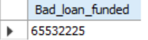
Bad Loan Amount Received
SELECT sum(total_payment) as Bad_loan_AMT_Received From Bank_oan_data
WHERE loan_status = "charged off";
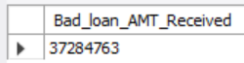

LOAN STATUS
SELECT loan_status,
Count(id) as NUM_Application ,
sum(total_payment)as Loan_paid, sum(loan_amount) as Loan_Issued,
round(avg(int_rate)*100,2) as AVG_Rate, round(AVG(dti)*100,2) as AVG_DTI
From Bank_oan_data group by loan_status; 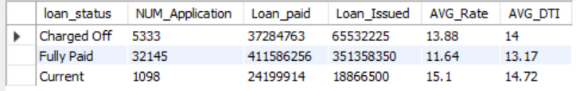
To show MTD Funded Amount and Received Amount
SELECT loan_status, sum(total_payment) as Received_AMT_MTD ,
sum(loan_amount) as Loan_Issued_MTD From Bank_oan_data
WHERE MONTH(issue_date)=12
group by loan_status ; 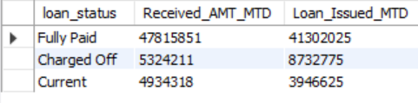

- BANK LOAN REPORT | OVERVIEW
MONTH
SELECT MONTH(issue_date) as Month_num, date_format(issue_date, "%M") as MONTH_name,
Count(id) as Total_Applicaiton, sum(total_payment) as Received_amount,
sum(loan_amount) as Loan_Issued
From Bank_oan_data
group by MONTH(issue_date), Month_name
order by MONTH(issue_date);

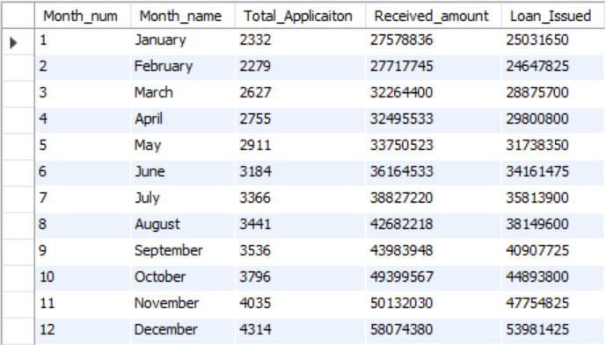

STATE
SELECT address_state, Count(id) as Total_Applicaiton,
sum(total_payment) as Received_amount, sum(loan_amount) as Loan_Issued
From Bank_oan_data
group by address_state
order by address_state;BY address_state
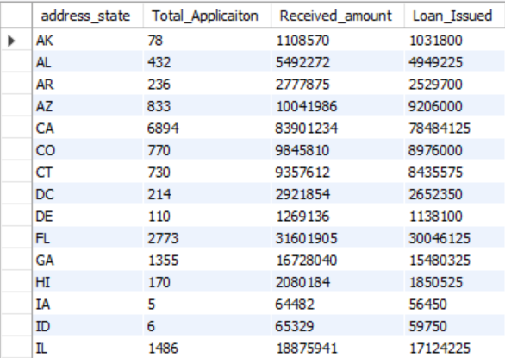

TERM
SELECT term as Term, Count(id) as Total_Applicaiton,
sum(total_payment) as Received_amount, sum(loan_amount) as Loan_Issued
From Bank_oan_data
group by term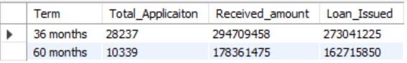

EMPLOYEE LENGTH
SELECT Emp_length as Employee_Length, Count(id) as Total_Applicaiton, sum(total_payment) as Received_amount, sum(loan_amount) as Loan_Issued
From Bank_oan_data
group by Emp_length
order by Emp_length;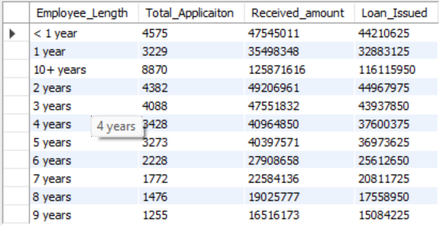

PURPOSE
SELECT purpose as Loan_Purpose,
Count(id) as Total_Applicaiton, sum(total_payment) as Received_amount,
sum(loan_amount) as Loan_Issued
From Bank_oan_data
group by purpose
order by purpose; 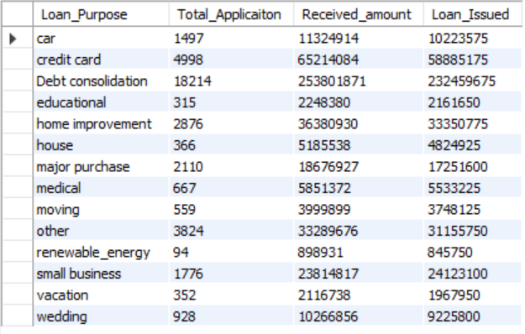

HOME OWNERSHIP
SELECT
home_ownership as Own_home,
Count(id) as Total_Applicaiton, sum(total_payment) as Received_amount,
sum(loan_amount) as Loan_Issued
From Bank_oan_data
group by home_ownership
order by home_ownership; 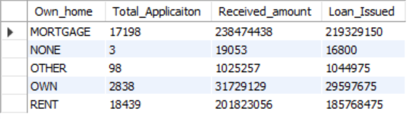

Note: We have applied multiple Filters on all the dashboards. You can check the results for the filters as well by modifying the query and comparing the results.
For e.g
See the results when we hit the Grade A in the filters for dashboards.
Query
SELECT purpose as Loan_Purpose, Grade, Count(id) as Total_Applicaiton, sum(total_payment) as Received_amount, sum(loan_amount) as Loan_Issued
From Bank_oan_data
WHERE grade= "A"
Group By purpose;

